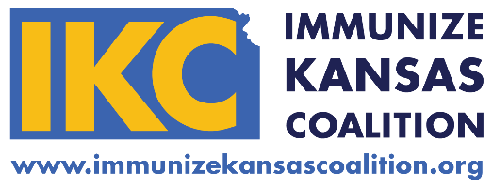
Welcome!
We’re glad you’re here.

Thanks for picking up an IKC Flash Drive - let’s get started:
In case there have been any revisions to the resources, you can always find the most up-to-date versions on our website.

This flash drive holds toolkits for increasing immunization rates for HPV, Meningococcal, Tdap, planning an HPV Community Education Event, and a folder with resources specifically for School Nurses.

Use the Flash Drive Directory document to quickly see what files are listed in each folder and find what you are looking for faster.

For each toolkit, you can find additional supporting resources and links on the IKC website. Hover over “Resources” in the header menu and select a toolkit from the drop down.

Make sure you are following us on Facebook, Twitter, and LinkedIn! We post positive, educational content about immunizations that you can share with your online communities. Social media is also how we get the word out about new or updated resources.

Lastly, if you have questions about these resources or suggestions for new resources, please email us at immkscoalition@gmail.com. We’d love to hear from you!

Thank you for engaging with IKC and working with us to protect Kansans from vaccine-preventable diseases!

